Onkar Dhillon

Dr. Chays

CSC 175

February 14, 2023

SumAndAverageCalculator.java output:

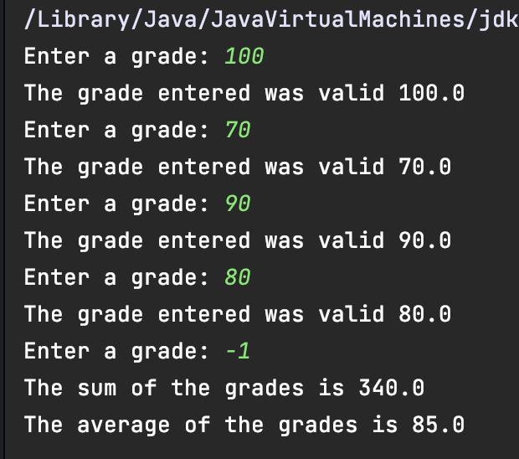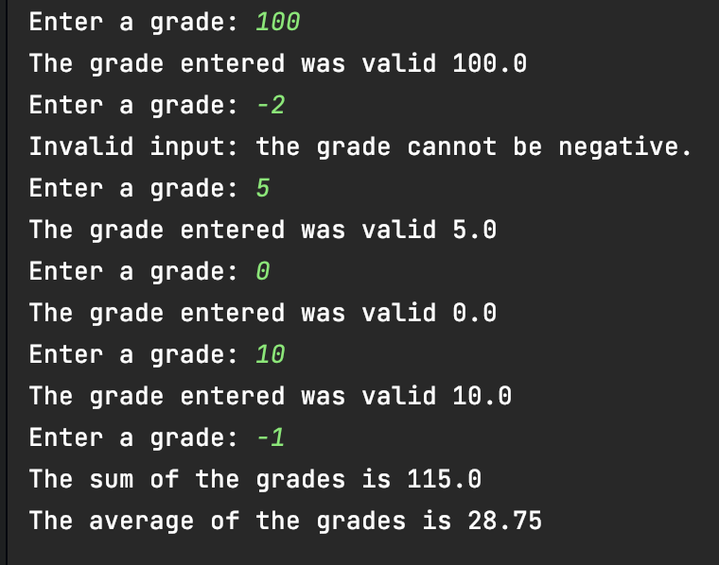

LoopedPrimitiveArtDesign.java

